CS 499 Module One Assignment
Brandon Shank
Date: 05/04/2026

- Self-Introduction: Address all of the following questions to introduce yourself.

  - How long have you been in the Computer Science program?

I have completed approximately 2 years of coursework in the Computer Science program. Through the coursework, I have learned enough to design, develop, and test software that can be usefully applied in practical settings. Additionally, I have strong data analysis and data visualization skills to effectively communicate my results.

  - What have you learned while in the program? List three of the most important concepts or skills you have learned.

After reflection, I have identified the following three key technical skills that I have developed:

      - Software design and modular programming, including structuring code for maintainability and scalability.
      - Database design and integration, including working with MongoDB and performing CRUD operations.
      - Algorithmic thinking and problem solving, particularly through reinforcement learning and performance optimization.

  - Discuss the specific skills you aim to demonstrate through your enhancements to reach each of the course outcomes.

The enhancements to the current system will further develop the functionality of the bot, in addition to imparting software engineering skills such as proper code organisation, modularity, and testing, along with algorithmic skills related to optimisation and improvement of reinforcement learning algorithms. These enhancements will also utilise database skills for query optimisation, data aggregation, and validation. The enhancements to the current system will address the following course outcomes: (a) able to explain the key concepts and steps involved in developing a software solution to a non-expert audience; (b) apply problem solving skills to real world problems; (c) design and document a system architecture to solve a real world problem; (d) apply technical implementation skills to develop a software solution; and (e) demonstrate an awareness of security considerations in software.

  - How do the specific skills you will demonstrate align with your career plans related to your degree?

Many of the skills covered in the Data Science Bootcamp are also relevant to software development, particularly for back-end and full-stack development, and designing and optimizing systems to manage large datasets.

  - How does this contribute to the specialization you are targeting for your career?

This experience demonstrates backend and full-stack development concepts. It shows you how to interact with databases and enhance an existing application into a full-stack system, which is what this specialization is focused on.

- ePortfolio Set Up:

  - Submit a screen capture of your ePortfolio GitHub Pages home page that clearly shows your URL.
    - You already have a repository in GitHub where you uploaded projects in previous courses. Your ePortfolio will reside in GitHub but can link to work at other sites, such as Bitbucket.

  - Use the GitHub Pages link in the Resource section for directions on:
    - How to create your GitHub website and publish code to GitHub Pages
    - Issues, such as adding links to other sites

  - Paste a screenshot of your GitHub Pages home page with your URL clearly showing in the space below.

I followed the steps on how to publish a GitHub Pages site from the course resources to upload my ePortfolio site. Additionally, I read about how to set up GitHub Pages from the settings on your repository, uploaded the published site from the main branch, and read about organizing and linking files for the portfolio.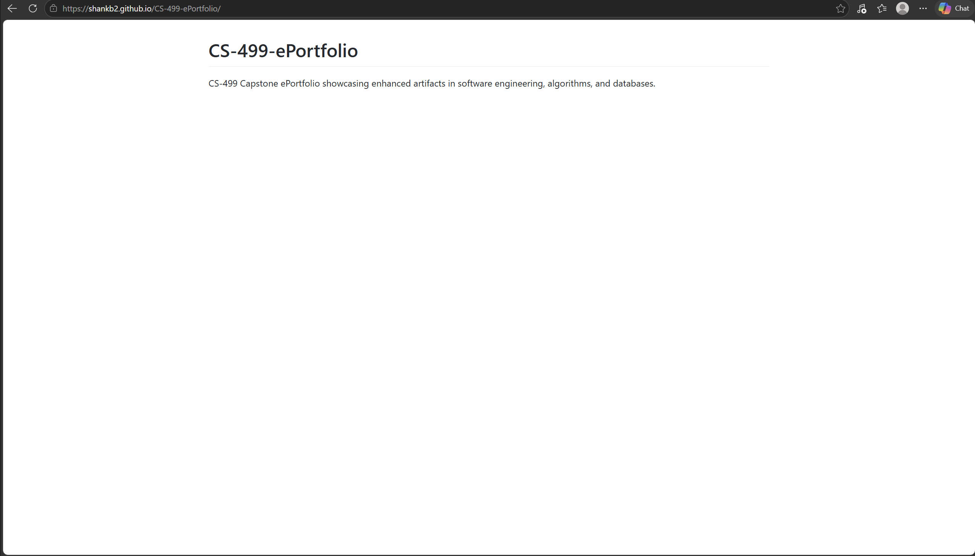

- Enhancement Plan:

  - Category One: Software Engineering and Design
    - Select an artifact that is aligned with the software engineering and design category and explain its origin. Submit a file containing the code for the artifact you choose with your enhancement plan.

CS-320: Software Testing, Automation, and Quality Assurance – Software Application Test Artifacts for Level of Testing and Validation from Unit Testing.
Project that used structured testing methods to write and document software application unit tests.

This project was set up to test programs and ensure that they worked from a set of test cases. The test case making, running of the tests were all correct, however the design of the software itself did not follow correct software engineering practices and there is room for improvement.

This was an earlier version of my work that demonstrated software design, modularity, maintainability and testing software engineering practices.

    - Describe a practical, well-illustrated plan for enhancement in alignment with the category, including a pseudocode or flowchart that illustrates the planned enhancement.

Planned enhancements include:

- Expanding unit test coverage to ensure reliability
- Implementing structured input validation and error handling
- Improving documentation and code readability
- Separating testing logic from application logic

Pseudocode for Software Design Enhancement:

START APPLICATION

INITIALIZE application_modules
INITIALIZE test_suite

FUNCTION validate_input(user_input)
IF user_input IS invalid THEN
RETURN error_message
END IF
RETURN validated_input
END FUNCTION

FUNCTION process_application(validated_input)
PERFORM core application logic
RETURN results
END FUNCTION

FUNCTION run_tests()
FOR each test_case IN test_suite DO
EXECUTE test_case
VERIFY expected_output
END FOR
END FUNCTION

MAIN
GET user_input
SET validated_input ← validate_input(user_input)
SET results ← process_application(validated_input)
CALL run_tests()
DISPLAY results
END MAIN

END APPLICATION

    - Explain how the planned enhancement will demonstrate specific skills and align with course outcomes.

      - Identify and describe the specific skills you will demonstrate that align with the course outcome.

This enhancement will demonstrate a few software engineering skills. First, the refactored application will be split up into separate modules (or packages), showing how to apply separation of concerns and a good modular design, leading to much better maintainability and scalability.

This work will extend unit test coverage to demonstrate designing and testing in a structured fashion. Testing correct functionality as well as edge cases and other system anomalies to improve overall system reliability.

Also learning input validation and error handling in order to safely and securely handle any invalid or unexpected input.

Improved documentation and code readability, as shown below, demonstrates my ability to effectively explain very technical content, making the project more understandable to other programmers and to non-programmers who are involved with the project.

This new set of features demonstrate design, testing and validation skills as well as general software design practices for a professional programmer.

      - Select one or more of the course outcomes below that your enhancement will align with.

The planned enhancement aligns with the following course outcomes:

- Outcome 2: Students will develop plans, designs, productions and implementations of oral, written and visual communications for general audiences and for peers, colleagues and clients from a variety of disciplines with various professional needs and expectations at levels appropriate for completion of associate's, bachelor's or advanced degrees; meetings professional standards of quality and coherence; and demonstrating technical proficiency.
- Students will be able to develop solutions to problems using algorithms and good computing practices and standards within a given constraint. Students will be able to evaluate design decisions and the corresponding trade-offs that make good software.
- Outcome 4: Apply a variety of sound and innovative techniques, skills, and tools to computer practices and apply them to produce value and address the goals of the information industry.
- Outcome 5 – Develop a security consciousness and apply that to design software architecture and identify vulnerabilities. This outcome will focus on addressing design flaws as well as issues related to privacy and security of data and resources.

  - Category Two: Algorithms and Data Structures

- Select an artifact that is aligned with the algorithms and data structures category and explain its origin. Submit a file containing the code for the artifact you choose with your enhancement plan. You may choose work from the courses listed under Category One.

This is my Pirate Intelligent Agent project completed for my CS-370: Current and Emerging Trends in Computer Science course. The project used reinforcement learning to train an intelligent agent to navigate a simple maze and find as much treasure as possible.

This repository contains an AI script, implemented in Python using the Keras library, which was used to solve an algorithmic problem using deep Q-learning techniques to try to find an optimal balance between exploration and exploitation and generally make better decisions based on rewards. The script was chosen because it is an interesting example of how to optimize an algorithm and its performance and make data-driven decisions.

- Describe a practical, well-illustrated plan for enhancement in alignment with the category, including a pseudocode or flowchart that illustrates the planned enhancement.

The next update should improve the efficiency and training speed of the reinforcement learning algorithm. In this update the hyperparameters of the algorithm should be tuned and there should be some improvements to how performance is tracked. I shall also include a comparison of the performance of the system before and after the update.

Planned enhancements include:

- Exploration rate decay in deep deterministic policy gradients (DDPG) and deep Q-network (DQN) is studied and improved in this article.
- Track win rate, loss rate, total episodes played, and average steps to win.
- One of the best ways to make training feedback more effective is to consider performance during and after training.
- Comparing the original and enhanced agent performance

Pseudocode for Algorithm Enhancement:

INITIALIZE environment
INITIALIZE agent
INITIALIZE performance_metrics

FOR each episode FROM 1 to N DO
RESET environment
SET total_reward ← 0

WHILE episode is not complete DO
SELECT action using epsilon-greedy strategy
EXECUTE action
OBSERVE reward and next_state

STORE (state, action, reward, next_state) in replay_memory
TRAIN model using replay_memory

UPDATE state ← next_state
UPDATE total_reward ← total_reward + reward
END WHILE

UPDATE exploration_rate (epsilon decay)
RECORD performance_metrics
END FOR

EVALUATE and COMPARE results
DISPLAY performance outcomes

- Explain how the planned enhancement will demonstrate specific skills and align with course outcomes.

  - Identify and describe the specific skills you will demonstrate to align with the course outcome.

The planned enhancement will demonstrate key skills in algorithm optimization, performance evaluation, and data-driven decision making. I will improve the reinforcement learning agent by adjusting hyperparameters and analyzing how these changes impact performance. This includes evaluating metrics such as success rate, episode completion time, and reward per episode. I will also demonstrate the use of appropriate data structures, such as replay memory buffers, to improve training efficiency and overall system performance.

Next, I will implement improvements to the reinforcement learning agent by refining algorithm behavior and evaluating performance outcomes. We’ll then go into how we can further optimize the algorithm to balance exploration and exploitation. We’ll also experiment with different hyperparameters (exploration rate, training frequency, etc.) and talk about the results.

In addition to learning a rewards based reinforcement learning algorithm, tracking metrics such as success rate, episode completion time and reward per episode will also help to demonstrate the ability to evaluate the performance of an algorithm using data. This will be compared against the performance of the original algorithm in order to highlight the performance gains and losses.

The next improvement will cover how to use appropriate data structures, such as replay memory buffers, to train the network. We will go over how to store and re-use experiences to train the network more effectively.

These improvements show that I can now optimize algorithms as well as test their performance, and also understand how to apply basic data structures to solve problems.

  - Select one or more of the course outcomes listed under Category One that your enhancement will align with.

The planned enhancement aligns with the following course outcomes:

- Outcome 3 - This assignment allows the student to put into practice the ability to design and test a program that solves a given problem, utilizing algorithms, Computer Science concepts, and best practices and standards appropriate to that solution. Throughout the design, coding, and revising of the program, the student makes a variety of decisions that affect the efficiency of the final product, and the sum of those decisions affect the final product's quality.
- Outcome 4: Students will apply well-established and innovative methods, skills, and tools in actual computer practice to solve computational problems to meet the industry needs and objectives much to the same extent that a professional in the computing industry can.

  - Category Three: Databases

    - Select an artifact that is aligned with the databases category and explain its origin. Submit a file containing the code for the artifact you choose with your enhancement plan. You may choose work from the courses listed under Category One.

For the artifact that I selected for this assignment, I decided to go back to a project that I had done in my CS-340: Advanced Programming Concepts class. For that project, I had created an Animal Shelter Dashboard application using Python to create a module to perform CRUD operations (found in CRUD_Python_Module.py) and performed the storage of the data in a MongoDB database. I also created a Jupyter Dash web interface where users would be able to view the information and filter through the different data categories.

Initially, we built a simple application to add, remove and update items and then visualise the results with some filters. However, our initial attempt hit some walls when it came to building something more scalable, more modular, and more maintainable, as too much of the code was getting intertwined with the web interface and database operations.

    - Describe a practical, well-illustrated plan for enhancement in alignment with the category, including a pseudocode or flowchart that illustrates the planned enhancement.

This enhancement will require refactoring and redesign of the existing application to make it more modular, maintainable and scalable. The system will be reorganised on a layer basis with separate layers for the database, business functionality and the user interface.

Enhancements will include:

- Separate out your CRUD code using a data access layer.
- Introducing a service layer to handle business logic
- Improving error handling and validation
- Enhancing code readability and documentation
- Preparing the system for future scalability and reuse

Pseudocode for Database Enhancement:

START APPLICATION

INITIALIZE database_connection
INITIALIZE user_interface

FUNCTION get_animals(filter_criteria)

SET results ← data_access_layer.read(filter_criteria)
RETURN results

END FUNCTION

FUNCTION process_data(data)
VALIDATE data
CLEAN data
APPLY business_rules
RETURN processed_data
END FUNCTION

FUNCTION display_dashboard()
GET filter_criteria FROM user_input
SET raw_results ← get_animals(filter_criteria)
SET processed_results ← process_data(raw_results)
DISPLAY processed_results ON dashboard
END FUNCTION

MAIN
CALL display_dashboard()
END MAIN

END APPLICATION

    - Explain how the planned enhancement will demonstrate specific skills and align with course outcomes.

      - Identify and describe the specific skills you will demonstrate that align with the course outcome.

This project demonstrates my skills in handling databases and managing data. I will improve MongoDB queries by organizing and optimizing them to retrieve accurate data efficiently. I will also refine query filters to reduce unnecessary data processing. Additionally, I will use aggregation pipelines to analyze and summarize data, providing meaningful insights. Input validation will be implemented to prevent invalid or harmful data from being processed. These improvements demonstrate my ability to perform database optimization, data validation, data analysis, and system integration in a real-world setting. All these improvements demonstrate that I can optimize databases, validate data, analyze data, and integrate systems in a real-world setting. By doing this, I will be able to make the database run more efficiently and provide more accurate results. This will also help me learn how to handle large amounts of data and make sense of it, which is a valuable skill in today's data-driven world.

In addition to adopting a more security conscious mindset, input validation can also be performed before submitting any invalid or malicious data to the database to ensure that no processing occurs on the database.

The improvements made in this revision show my ability to perform database optimization, data validation, data analysis, and integration in a real world scenario.

      - Select one or more of the course outcomes listed under Category One that your enhancement will align with.

The planned enhancement aligns with the following course outcomes:

- Outcome 2: The student will employ algorithms to solve a problem and, after consulting Computing Science best practices and ethical standards, design a computing solution (program) that meets the given requirements, and then test, evaluate features of the solution, and make design decisions and compromises to complete the final product.
- Outcome 4: Utilize a variety of well-established and innovative techniques, skills and tools that are pertinent to computing practices to produce value laden computer solutions for diverse industry applications.
- Outcome 5: Develop an awareness of security by identifying vulnerabilities, design points that an adversary might exploit, design errors that need to be prevented, and ensuring privacy and security of data and resources in practical software architectures and designs.

- ePortfolio Overall Skill Set

  - Accurately describe the skill set to be illustrated by the ePortfolio overall.
    - Skills and outcomes planned to be illustrated in the code review

Code review - demonstrates ability to analyze given code, find areas for improvement and suggest necessary changes. Ability to structure and describe given code and improvements for it is also demonstrated. I will also demonstrate my ability to explain the technical features of the system to peers and stakeholders and explain why those improvements are necessary.

These activities are designed to help me meet course outcomes related to the collaborative environment (Outcome 1) and professional communication (Outcome 2). In this activity, I will engage in a simulated code review where I discuss possible enhancements to the software.

    - Skills and outcomes planned to be illustrated in the narratives

The narratives document and justify the decisions made during the enhancement process. They explain why specific improvements were selected, how they were implemented, and the impact they have on the system. The narratives also connect the work to real-world applications and industry practices.

Solutions developed for this assignment will be assessed against course outcomes 3: Design and evaluate computing solutions and 4: Use effective tools and techniques to implement computing solutions. Additionally, the narrative documents will be evaluated based on my ability to clearly and effectively communicate solutions to a variety of professional audiences.

    - Skills and outcomes planned to be illustrated in the professional self-assessment

The professional self-assessment will demonstrate my growth in technical skills and my ability to learn and adapt throughout the Computer Science program. I will highlight my increasing proficiency in software engineering, algorithm design, and database management, and explain how these skills have been applied across different projects. I will also describe how these skills align with my career goals and industry expectations, and how I can effectively communicate my strengths and areas for continued development.

I will develop an awareness of the various skills in this category, how these skills relate to my own career goals and industry expectations, and how to effectively market their strengths and needs for professional development. These outcomes are addressed in course outcome 2 (Professional Communication) and outcome 4 (Technical Knowledge put into Practice).

